Mini Project - Data Analysis using Excel and Power BI

HR Raw Dataset - Kaggle: https://www.kaggle.com/datasets/divanshu22/hr-dataset
Cleaned Dataset: https://docs.google.com/spreadsheets/d/11zolbfBfxeCswxp0Zt0zOyEGE56MbSuJ/edit?usp=drive_link&ouid=107937566320316284951&rtpof=true&sd=true
Power BI Dashboard PDF:
https://drive.google.com/file/d/1SGEIEGkE7Y5O_3eTD9uJJ0GbeOU64IRR/view?usp=drive_link
Power BI Dashboard. pbix: https://drive.google.com/file/d/1M2YZxiR_DapyTTSMHK7Qly_twA-YvwF-/view?usp=drive_link

- Used drill-down for this matrix, where it is drilled down to Job Titles.
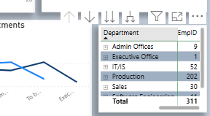

- Added a Filter to this visual.
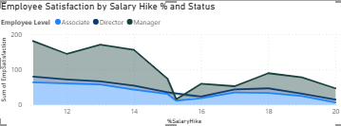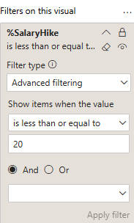

Below are the Columns and Measures created.
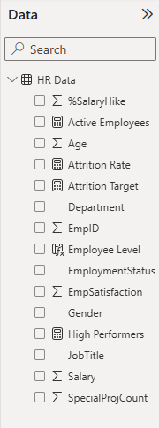
Employee Level = IF([Salary] > 100000, "Director", IF([Salary] > 60000, "Manager", "Associate"))

